Gilles de Rais: 0

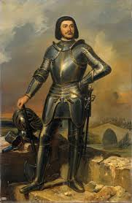

Elizabeth Bathory: 35

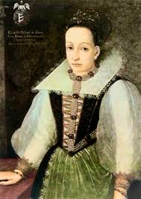

Maximillien de Robespierre: 57

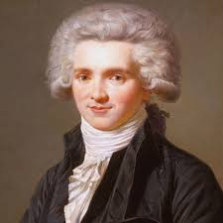

Thomas Brown: 90

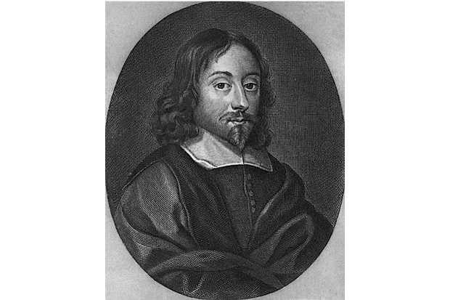

Charlotte Corday: 95

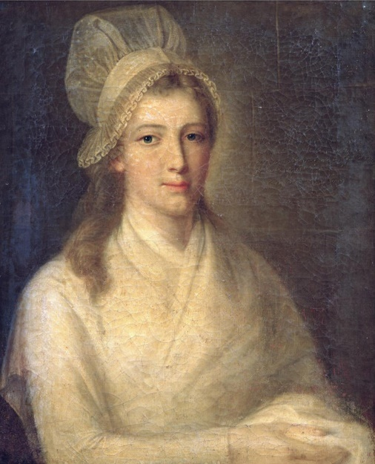

Lui Bengli: 99



Belle Gunness: 110

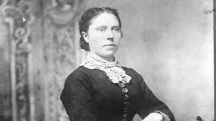

Thug Behram: 159

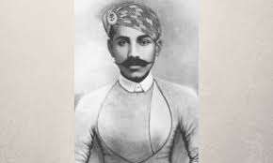

Avg Amount of Caffine Consumed per day:

0

35

57

90

95

99

110

159